HRH maps 2025

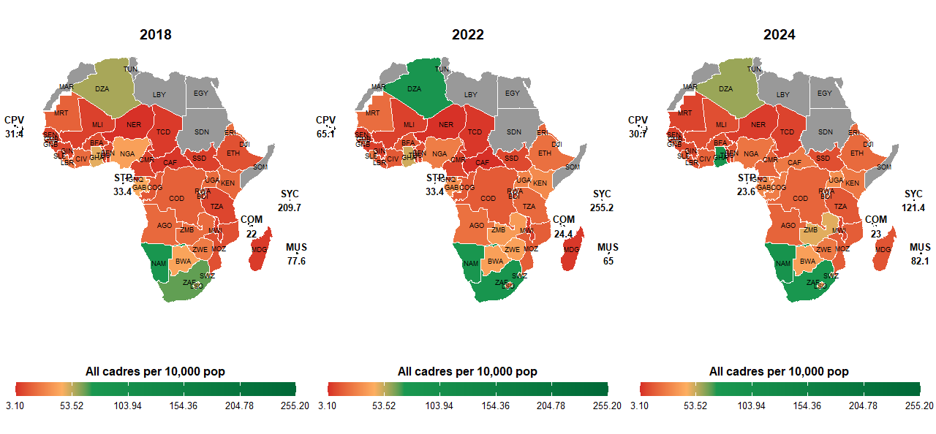
Health workforce…All cadres per 10,000 population.

I have got some breakthrough… the green starts from the threshold. For instance, I used 60% more that 44.5 which is for the 5 core cadres. And this is what is get. You can share the thresholds to use then, I will just run the codes again.

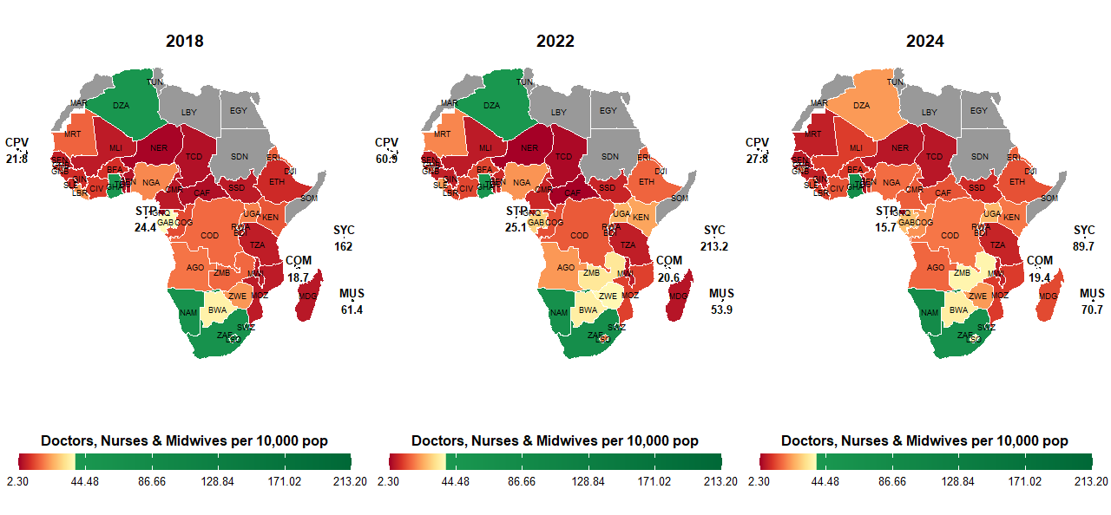

This Doctors, nurses and midwives, used a threshold of 35 since the doctors are 10, nurses at 23 and a margin for midwives per 10,000 population. You can also clarify this!

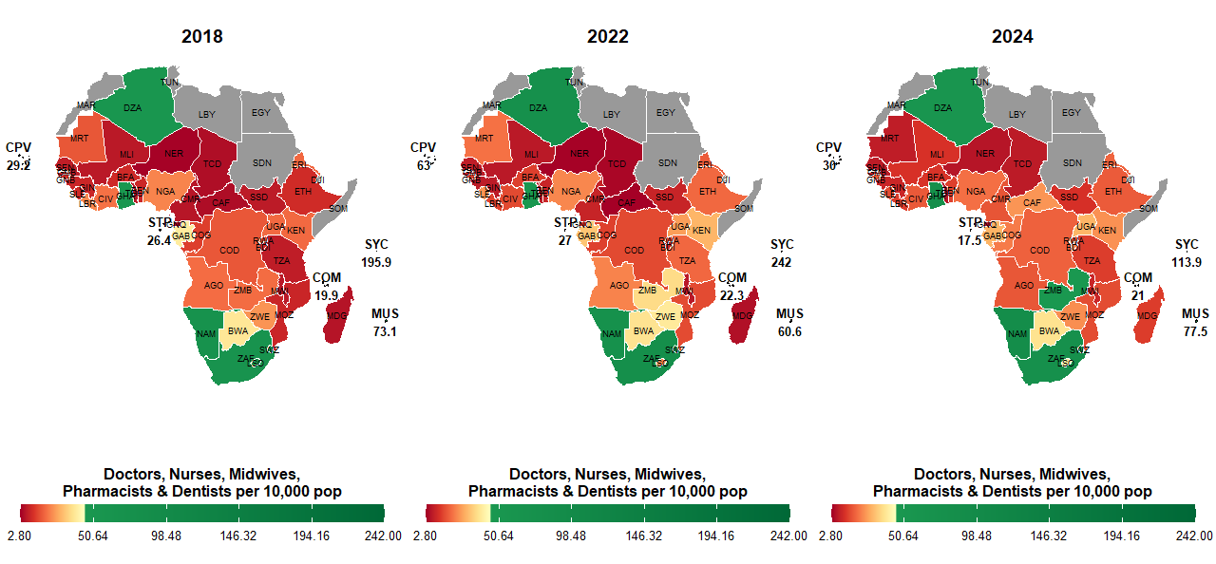
The threshold for this is 44.5 per 10,000 population

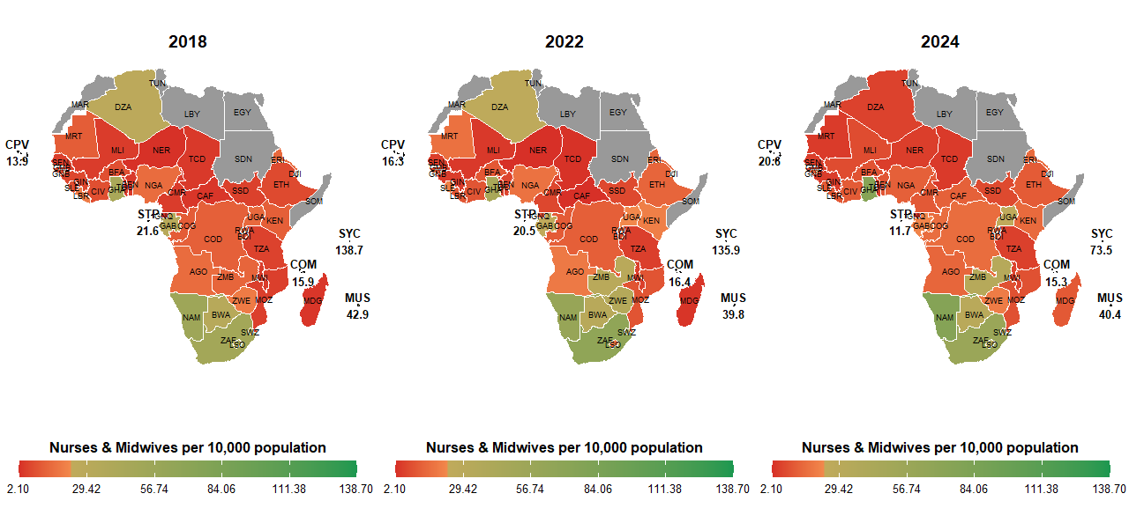
The threshold for the Nurses and midwives was takes as 23 per 10,000 population.
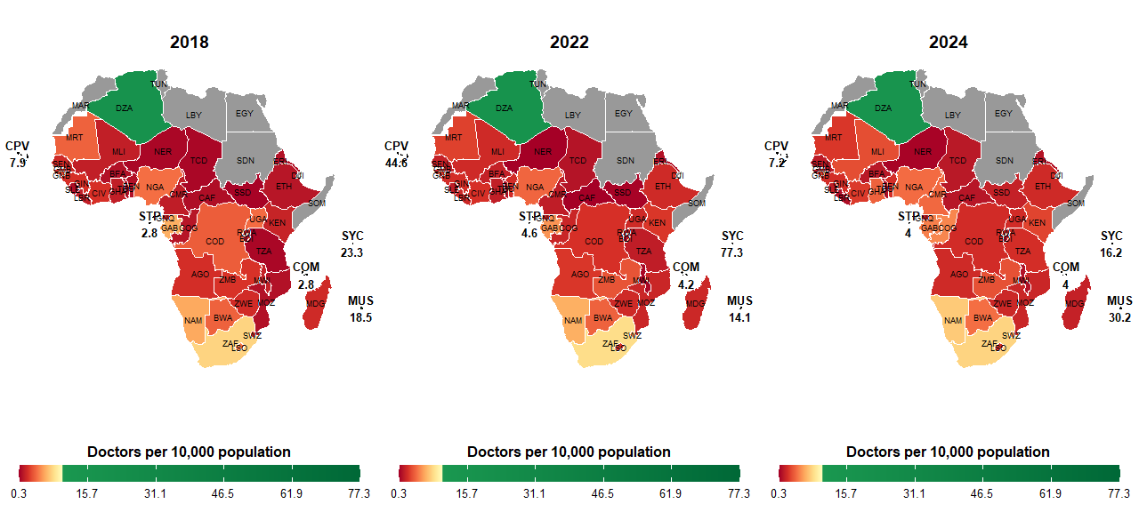

The threshold for doctors is 10 per 10,000 population.

